Git Notes
# Git: Creating & Switching Branches In Git
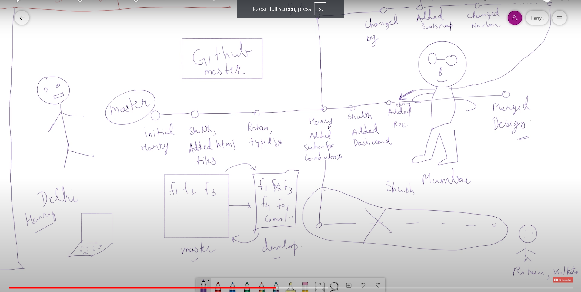
- "git checkout -b <branch-name>" command creates a new branch and changes the branch to the newly created branch.
# Branch Management
- git branch -> shows the current working branch.
- git branch -v -> shows hash of last commit and message of last commit did on the branch.
- git branch --merged -> shows already merged branches. these branches can be deleted as they are already merged.
- git branch --no-merged -> shows branches that are not merged. these branches can alsoo be deleted but a warning is shown beforehand.
- deleting branches
- git branch -d <branch-name> -> gives error if the branch is not merged.

